ADESCO TECH HUB ONLINE ACADEMY PROJECT
BY
ANGEL

Amazon LightSail Dashboard
Accessed Amazon Lightsail to begin deploying the Student Management Portal.
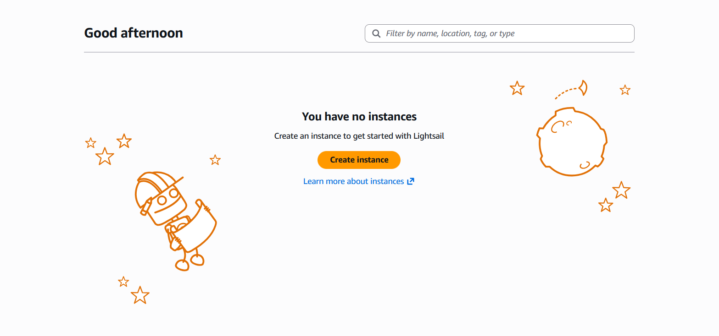

TASK 1
Lightsail Instance Created
Successfully created and launched an Ubuntu Lightsail instance to host the Student Management Portal.
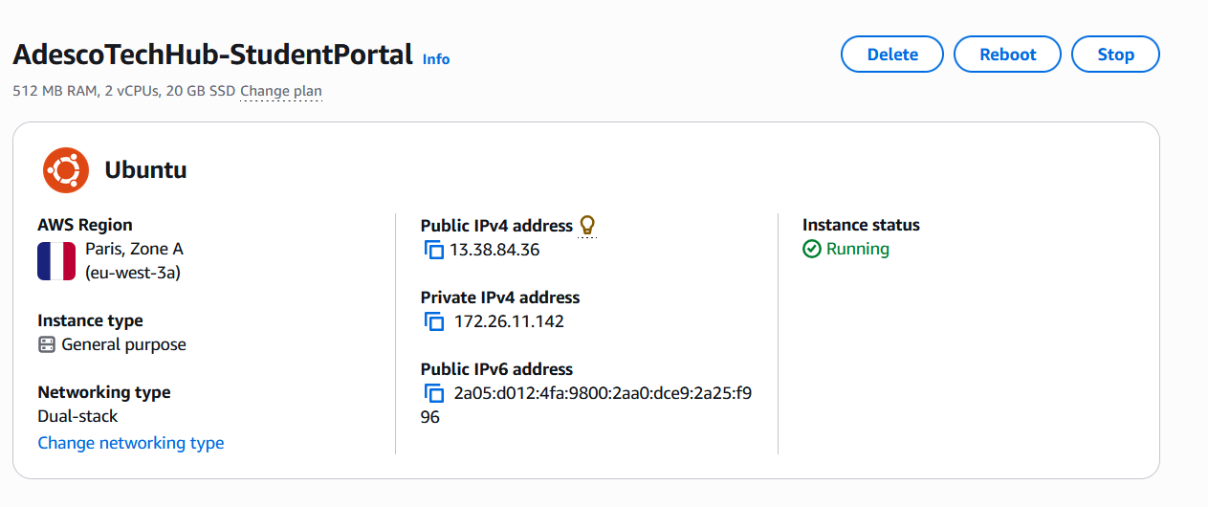

Connected to the Lightsail Instance
Successfully connected to the Ubuntu Lightsail instance using the browser-based SSH terminal.
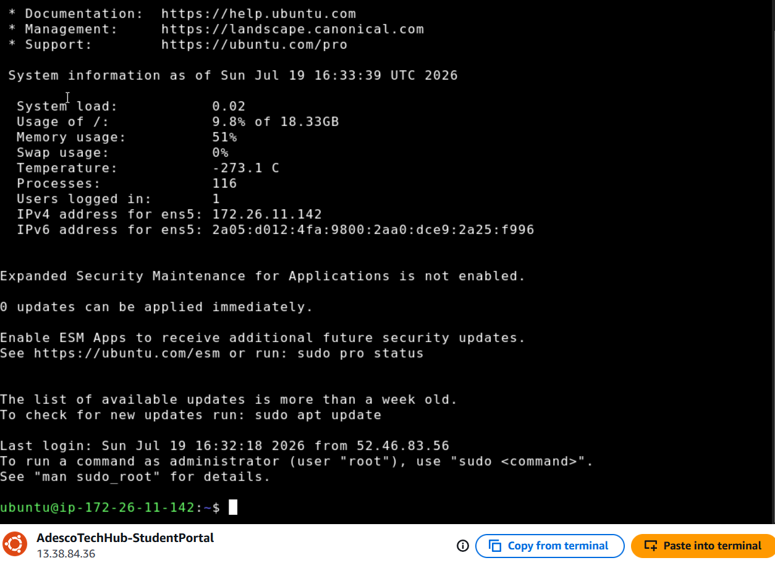
Apache Installation and Service Verification
Successfully updated the Ubuntu Lightsail instance and installed the Apache web server.
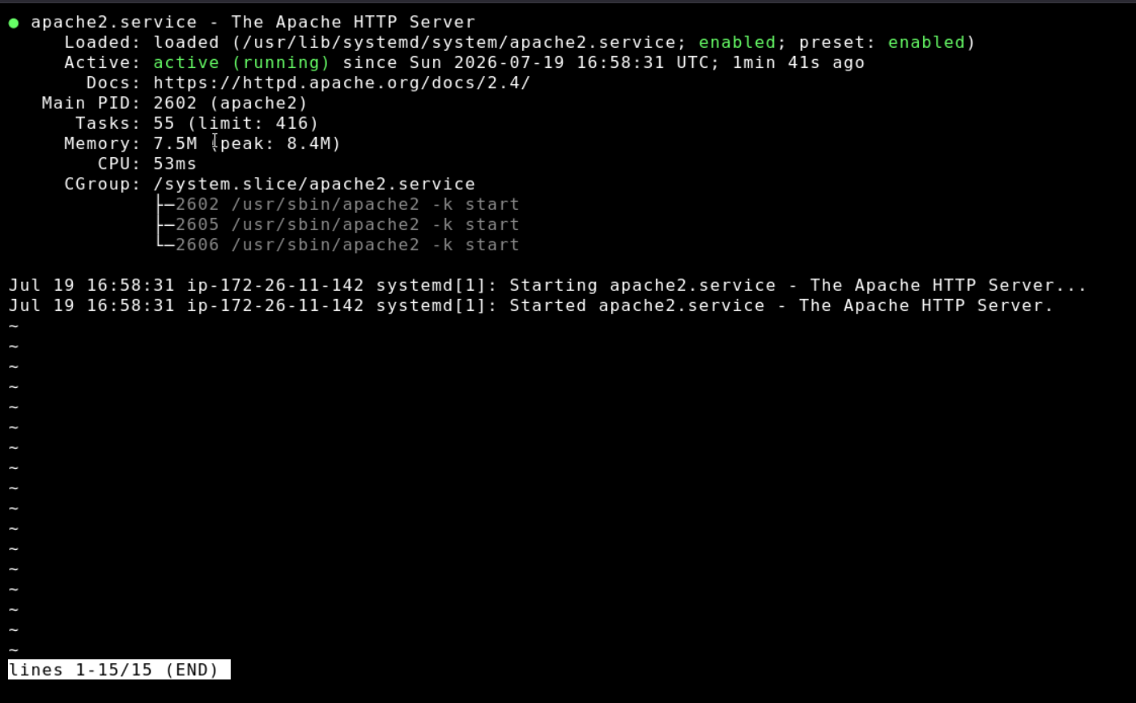
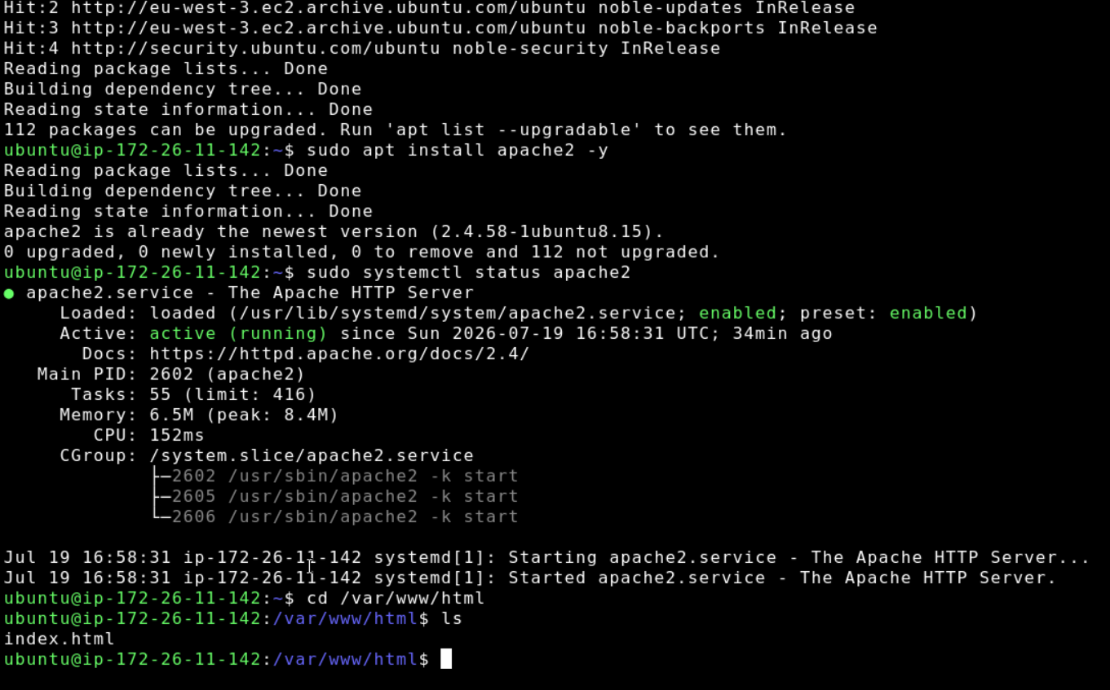

Student Management Portal Webpage
Created and saved the index.html file in the Apache web
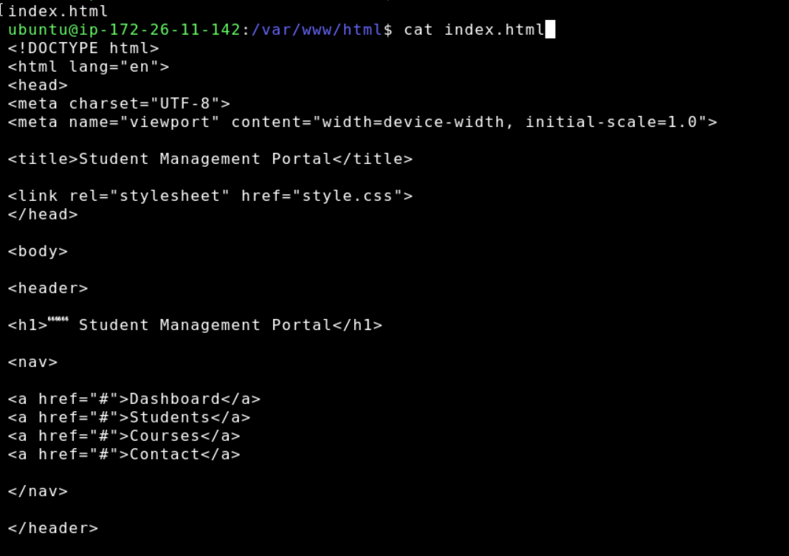

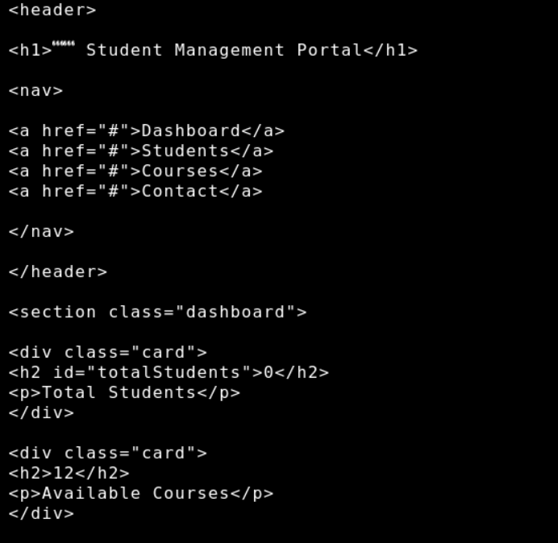

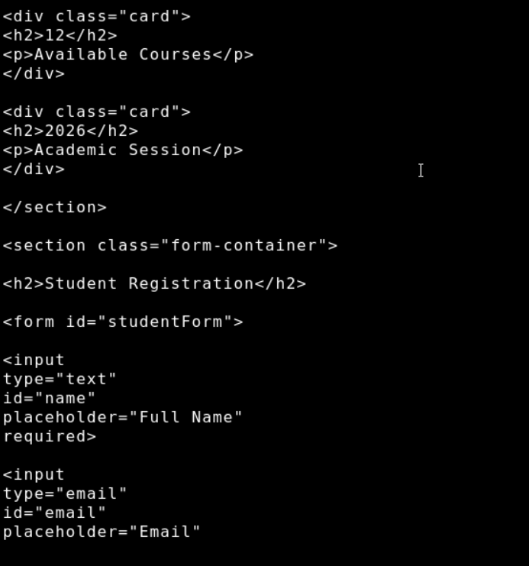

Student Management Portal Deployment
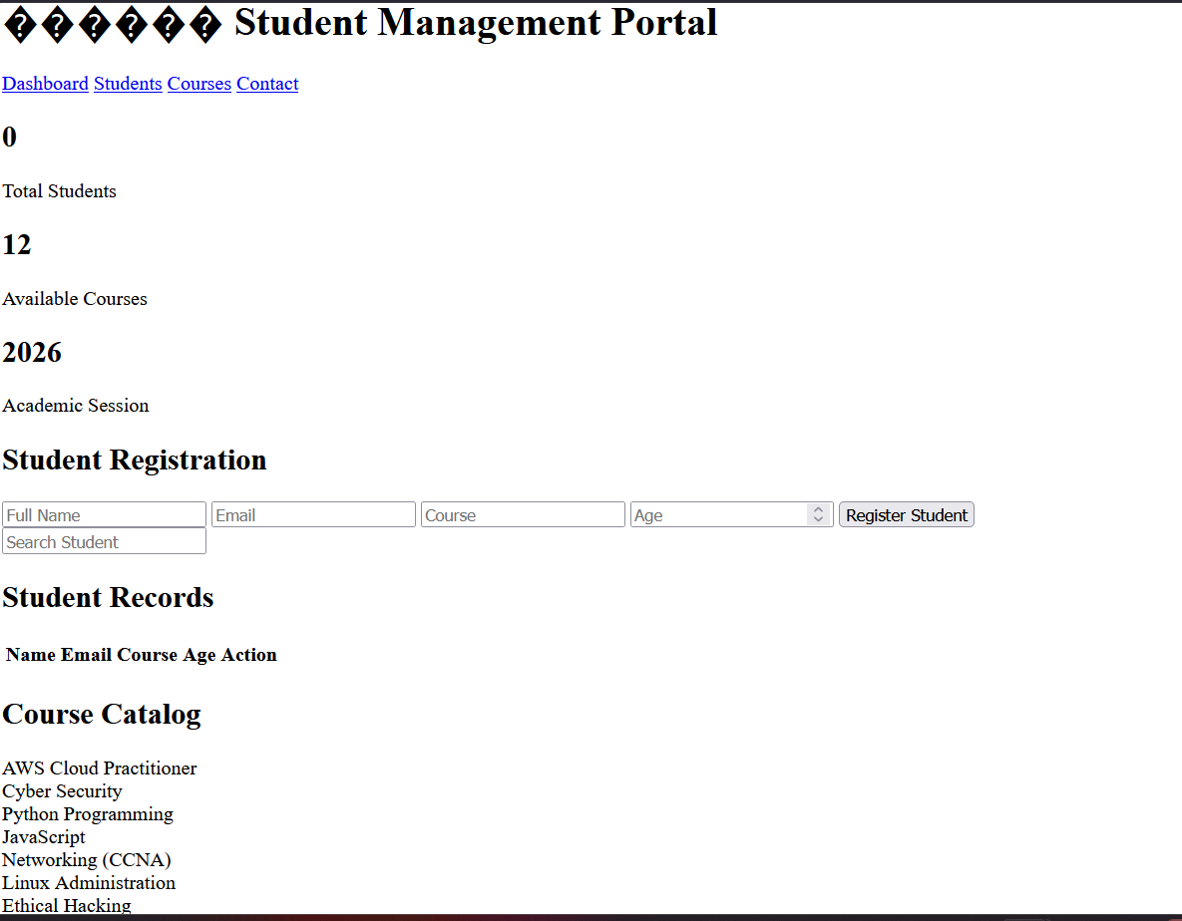

TASK 2: Students Table Creation
Created an Amazon DynamoDB table named Students with Student_ID as the partition key.
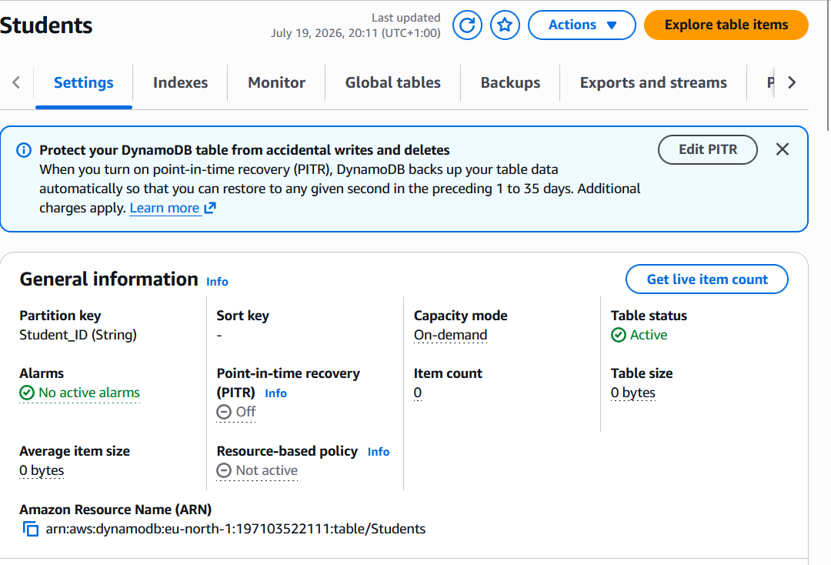

Student Records
Successfully created and stored student records in the Amazon DynamoDB Students table.
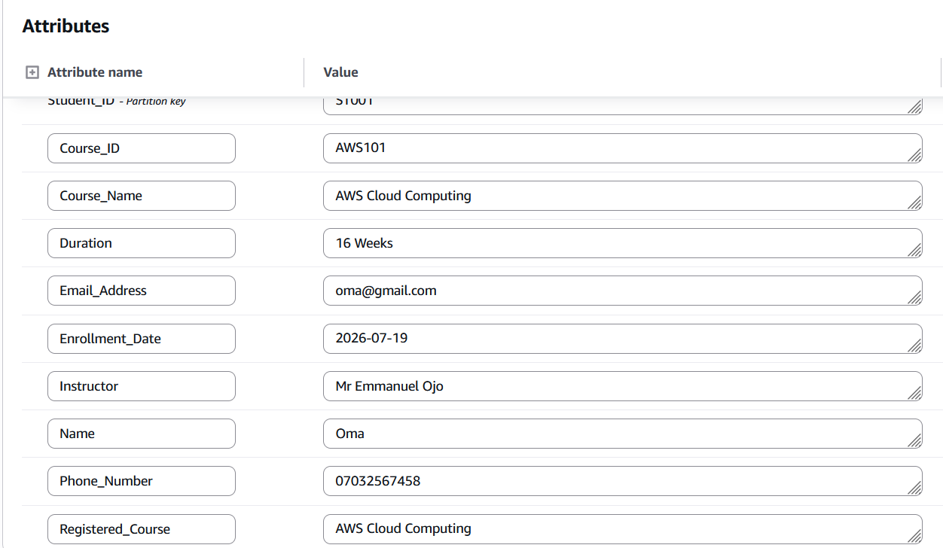

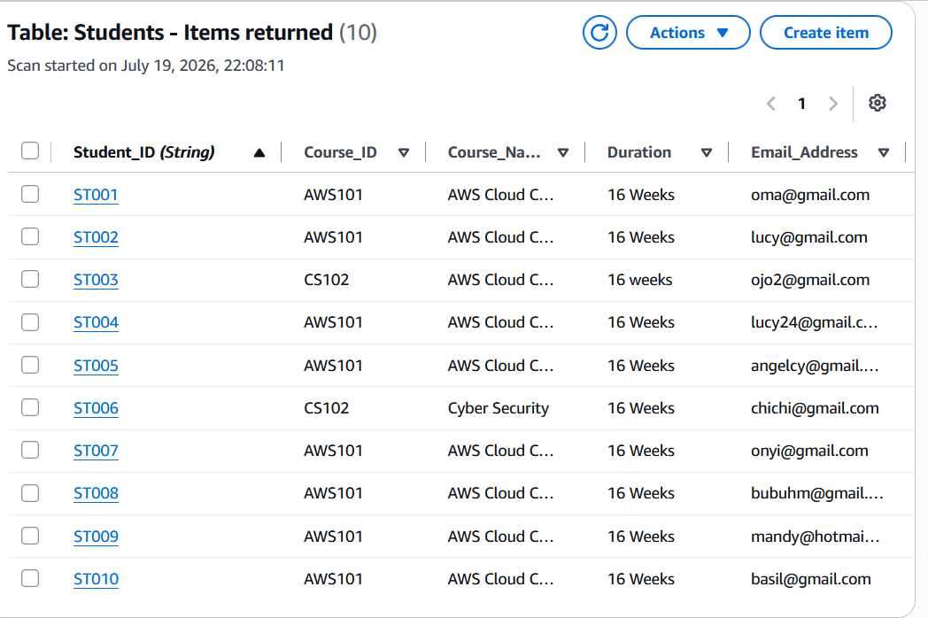
Task 2B: Attendance Table

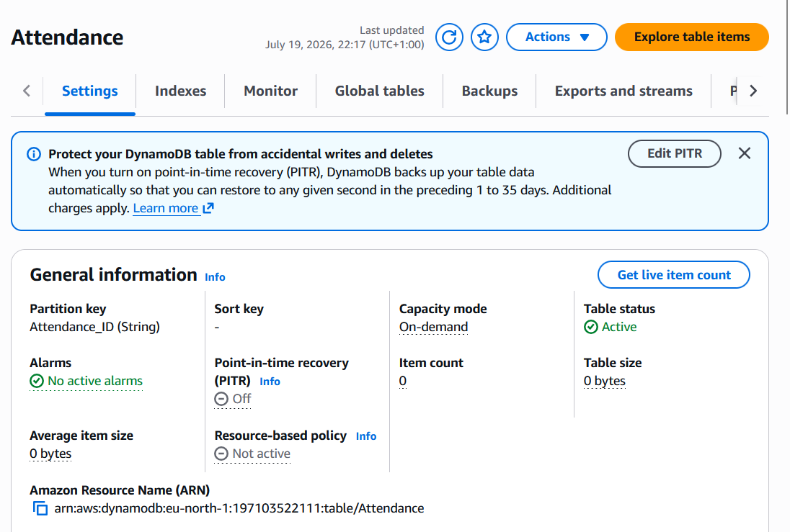

Created attendance records to monitor students' class attendance and learning activities.
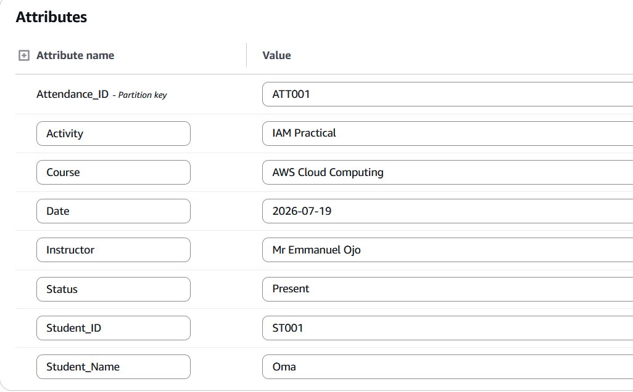
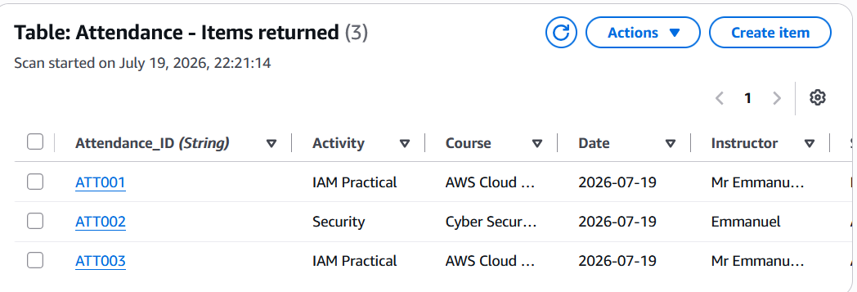

Task 3: AWS Lambda Function Creation
Successfully created a Lambda function named AdescoTechHub-Online-Academy using the latest version Python 3.14
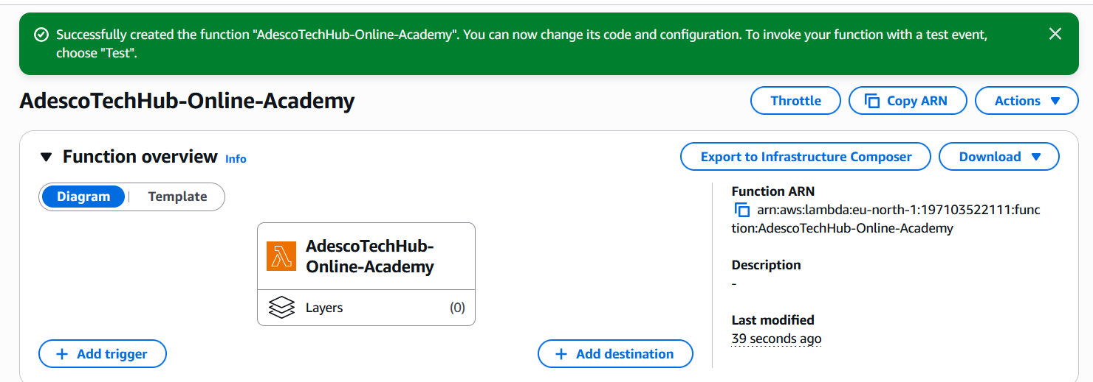

Task 3B: Lambda Function Deployment
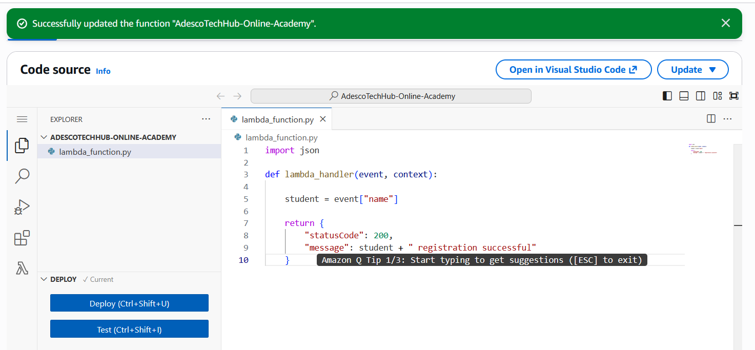

Task 3C: Lambda Function Test
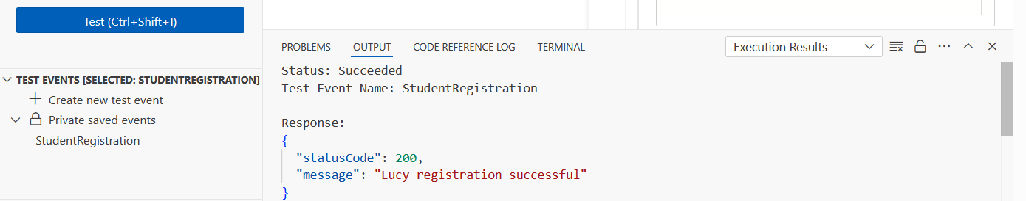

Task 4: CloudWatch Monitoring and Logs
